EASTERN INTERNATIONAL UNIVERSITY | Practice Assignment – Quarter 4, 2025- 2026
SCHOOL OF COMPUTING  AND INFORMATION TECHNOLOGY | Course Name: ISAD  Course Code: CSW 309
Student’s Full Name: Vũ Đức Tùng
Student ID: 2331200132

LAB 04

1. Problem Description and System Request
- Summarize the problem (why the system is needed).
Currently, event proposals and venue booking requests are handled through emails, paper forms, and informal messages. This unstructured workflow leads to lost requests, double booking of venues, unclear approval statuses, and difficulty tracking event history, which reduces the overall efficiency of campus administration.

  - Write the goal
To develop a centralized “ Campus Event and venue booking System” that allows student clubs and departments to easily seearch for venues, submit booking requests and track their request status, while enabling university staff to efficiently review and magage approvals.

  - Write 2–3 expected benefits.
+ Cancel double booking by providing real-time checking of venue availability.
+ Improves operational transparency by providing clear, trackable request statuses.
+ Reduce manual administrative effort and effectively archives event booking history for future reference.
2. Functional Requirements
List 5–7 main functional requirements of the system
- The system shall allow requesters to search for available venues and view request details such as capacity and facilities.
- The system shall allow requesters to submit an event booking request containing the event title, purpose, expected participants, preferred venue, event date, start time, end time, and required facilities.
- The system shall allow students affairs officer to review submitted requests, record comments and update the stattus.
- The system shall allow requesters to edit and resubmit a booking request that requires revision.
- The system shall allow the Facility Manager to approve or reject a valid booking request after checking venue availability and facility readiness.
- The system shall automatically send notifications to the requester when the booking status changes
3. Draw a Use Case Diagram
  - Identify actors: Requesters, Student Affairs officer, facility Manager.
  - Identify use cases: Search venues, submit booking request, Edit/ resubmit request, review request, Approve/Reject request, Update to Completed, Check Booking Status.
  - Draw the system boundary.
  - Show the relationship between actors and use cases
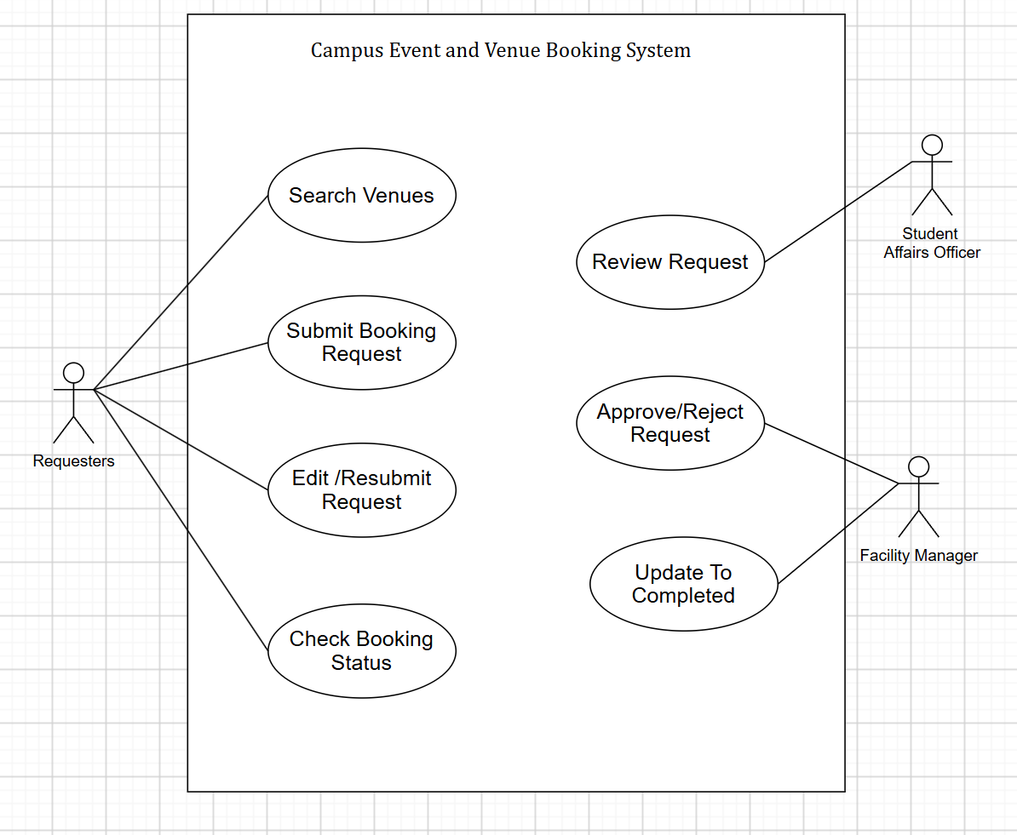
4. Data Flow Diagram
  - Identify external entities: Requesters, Student Affairs Officer, Facility Manager.
  - Identify 4–6 main processes.
1.0 Search Venues
2.0 Process Booking Request
3.0 Review Request
4.0 Manage Venue Approval
5.0 Complete Event.
  - Identify at least 3 data stores: D1 Requester Records, D2 Venue Records, D3 Event Booking Requests, D4 Facility Records, D5 Notification Records
  - Identify major data flows.
  - Draw one Level-0 DFD.

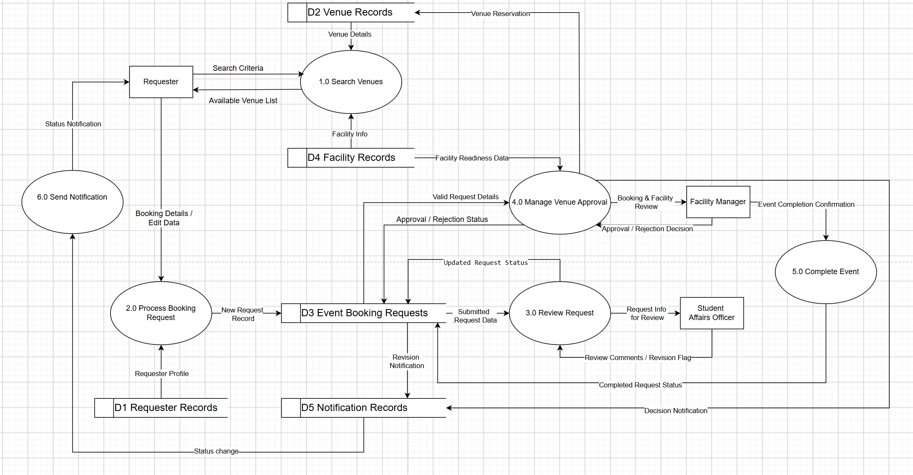
5. Entity–Relationship Diagram
  - Identify primary keys: RequesterID, VenueID, RequestID
  - Show important attributes:
- Requester: Name, Email.
- Venue: Capacity, Facilities.
- BookingRequest: EventTitle, Purpose, ExpectedParticipants, Date, StartTime, EndTime, Status.
  - Show relationships and cardinalities:
    - Requester (1) submits (N) BookingRequest
    - Venue (1) hosts (N) BookingRequest.
  - Draw one ERD

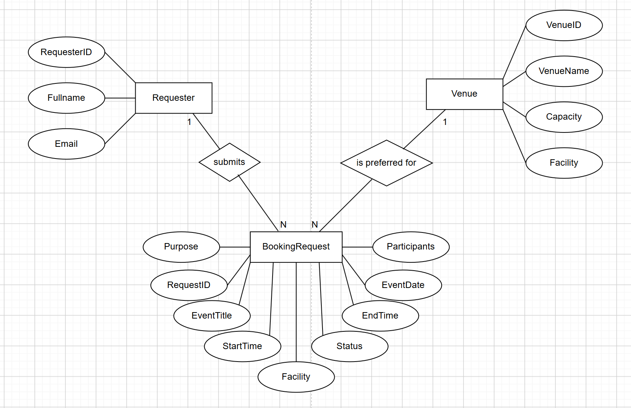
6. Basic Class Diagram
  - Draw one Basic UML Class Diagram based on the ERD.
  - Convert main entities into classes.
  - Add key attributes only.
  - Add only simple methods if appropriate.
  - Show relationships and multiplicities.
  - Use inheritance only if clearly justified.

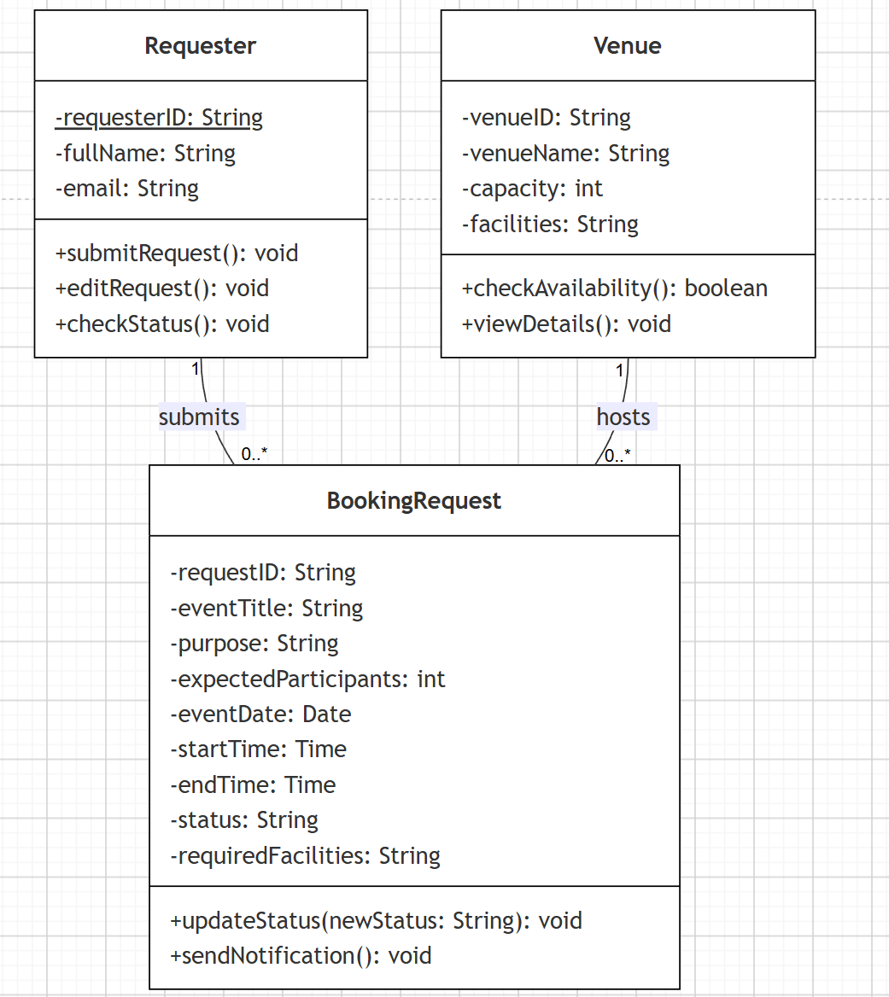
- Submission
- Submit one PDF file named: CSW309_Lab04_StudentID_Name.pdf
- The PDF must include:
  - Problem Description and System Request
  - Functional Requirements
  - Use Case Diagram
  - Level-0 DFD
  - ERD
  - Basic UML Class Diagram
  - Diagrams may be created using: StarUML, Visual Paradigm, draw.io / diagrams.net, PlantUML
Note:
- Keep all models simple, correct, and consistent with the given scenario.
- Focus on basic notation and logical correctness rather than design complexity.

